**Computer Organization and Architecture**

• Computer Architecture refers to those attributes of a system visible to the programmer or those attributes that have a direct impact on the logical execution of a program.

Examples of architectural attributes include the Instruction set, the number of bits used to represent various data types, I/O mechanisms, addressing techniques.

• Computer Organization refers to the operational units and their interconnections that realize the architectural specifications.

Organizational attributes include those hardware details transparent to the programmer, such as Control signals, interfaces between the computer and peripherals, and the memory technology used.

**Structure &** **Function**

• Structure is the way in which components relate to each other.

• Function is the operation of individual components as part of the structure.

**Function**

• There are only four basic functions that a computer can perform are:

—Data processing

—Data storage

—Data movement

—Control

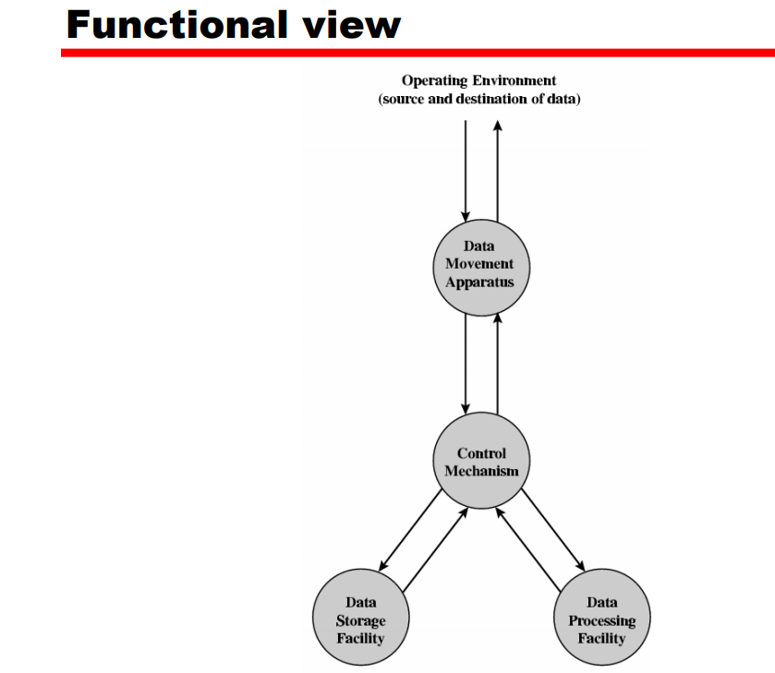

The computer must be able to process data. The data may take a wide variety of forms, and the range of processing requirements is broad.

It is also essential that a computer store data. There is at least a short-term data storage function and the computer performs a long-term data storage function. Files of data are stored on the computer for subsequent retrieval and update.

The computer must be able to move data between itself and the outside world. The computer’s operating environment consists of devices that serve as either sources or destinations of data.

Finally, there must be control of these three functions. With in the computer, a control unit manages the computer’s resources.

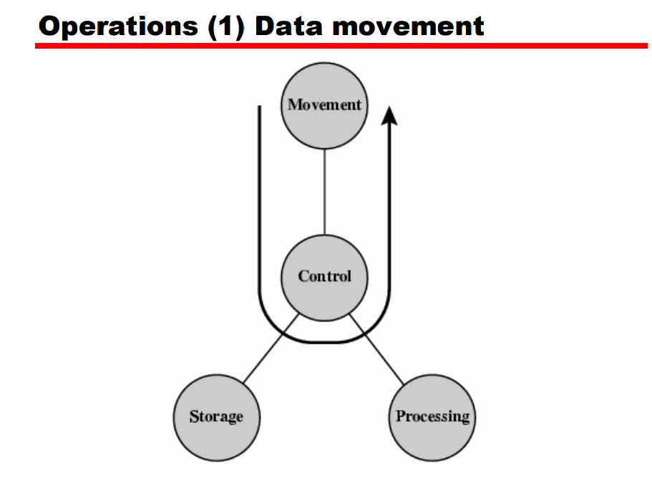

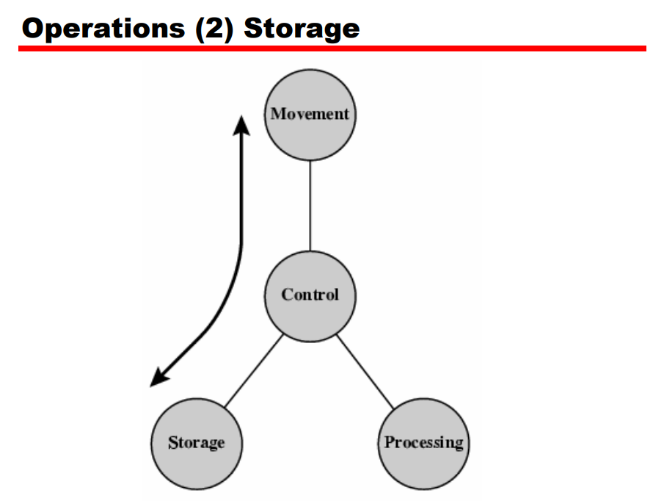

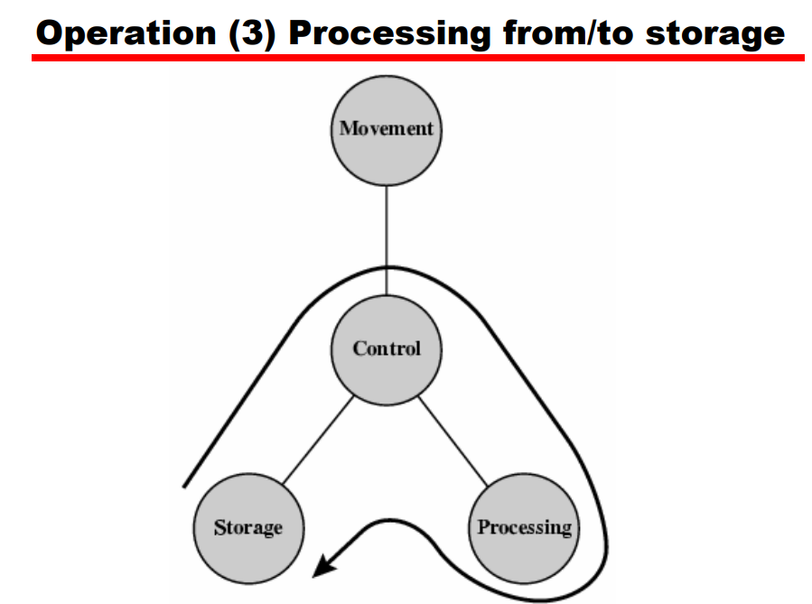

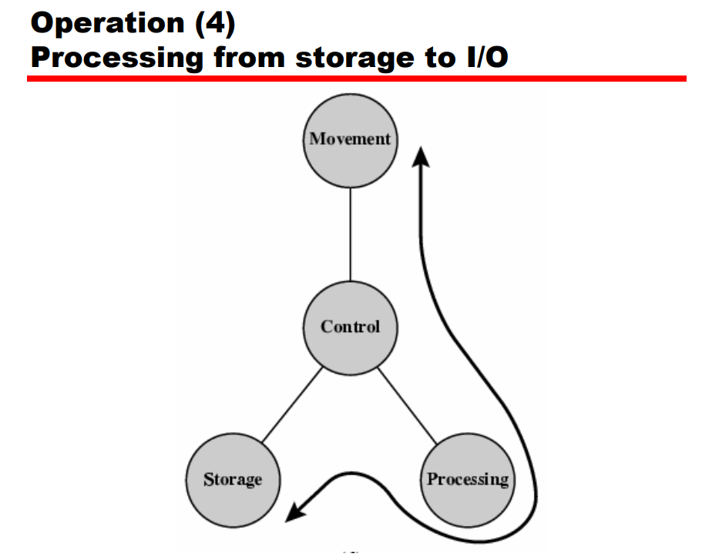

**Structure:**

The computer interacts in some fashion with its external environment.

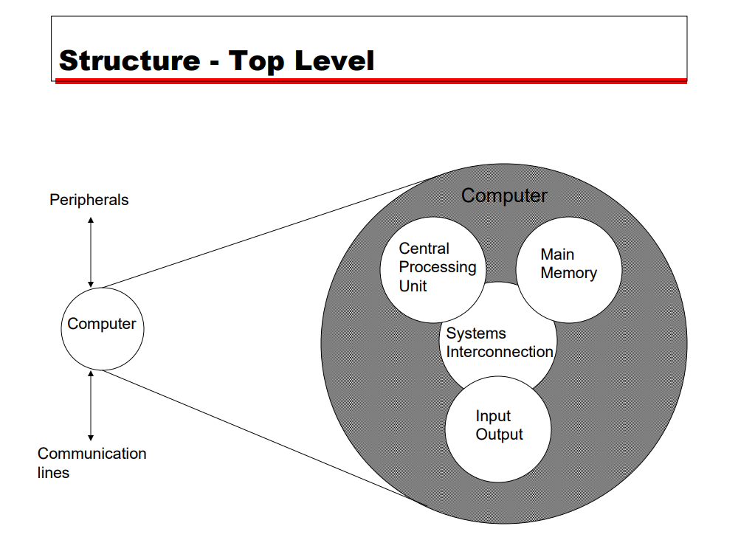

Central Processing Unit(CPU): Controls the operation of the computer and performs its data processing functions often simply referred to as processor.

Main memory: Stores data.

I/O: Moves data between the computer and its external environment.

System interconnection: Some mechanism that provides for communication among CPU, main memory, and I/O.

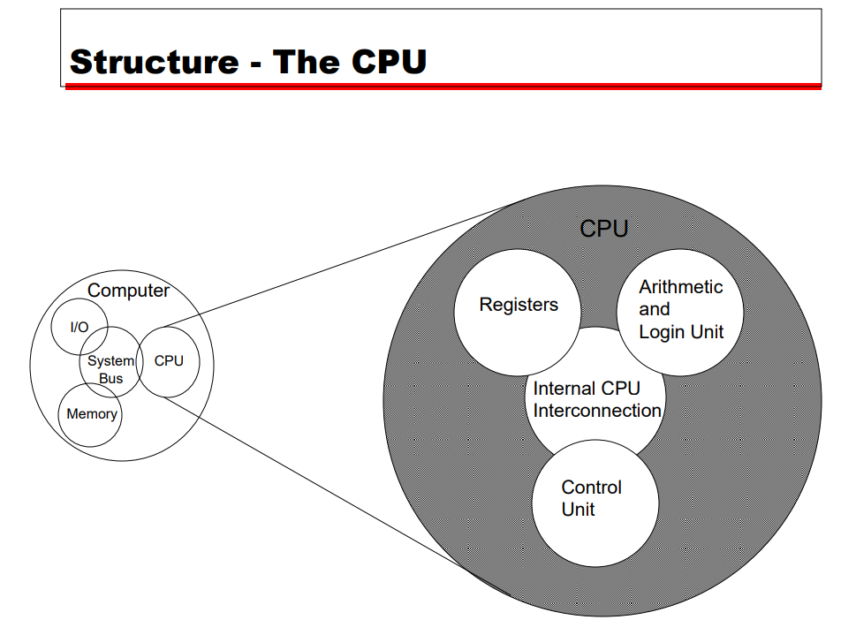

Control Unit: Controls the operation of the CPU and hence the computer.

Arithmetic and Logic Unit (ALU): Performs the computer’s data processing functions.

Registers: Provides storage internal to the CPU.

CPU interconnection: Some mechanism that provides for communication among the control unit, ALU and registers.

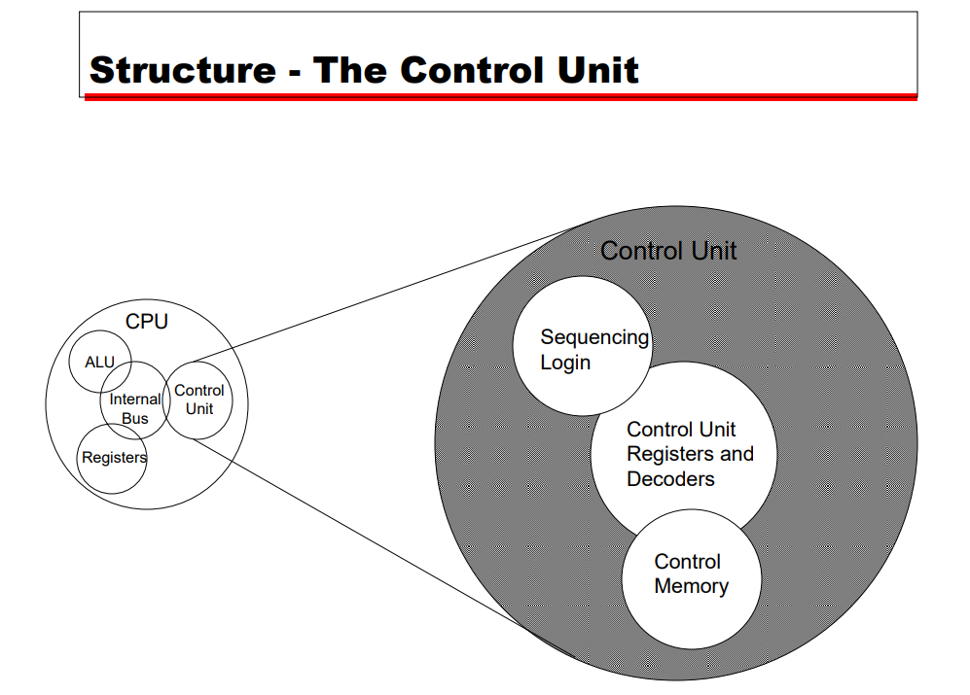

**Why to study computer organization and architecture?**

All students of computing should acquire some understanding and appreciation of a computer system’s functional components, their characteristics, their performance and their interactions. Students need to understand computer architecture in order to structure a program so that it runs more efficiently on a real machine.